**DESIGN AND IMPLEMENTATION OF A DIGITAL LIBRARY SYSTEM**

# TITLE PAGE

**BY**

**ABUBAKAR Mohammed JIBRIL**

**(ST/CS/ND/23/004)**

**YAHAYA Kedima**

**(ST/CS/ND/23/083)**

**DEPARTMENT OF COMPUTER SCIENCE,**

**SCHOOL OF SCIENCE AND TECHNOLOGY,**

**FEDERAL POLYTECHNIC, MUBI, ADAMAWA STATE.**

**IN PARTIAL FULFILLMENT OF THE REQUIREMENT FOR THE AWARD OF NATIONAL DIPLOMA (ND) IN COMPUTER SCIENCE.**

**JULY, 2025**

# DECLARATION

We hereby declare that the work in this project titled “**Design and Implementation of a Digital Library System**” was performed by us under the supervision of Mr. Mustapha Garba Sintali. The information derived from literature has been duly acknowledged in the text and a list of references provided. The work embodied in this project is original and has not been submitted in part or in full for any other diploma or certificate of this or any other institution.

ABUBAKAR Mohammed JIBRIL ________________ _______________

(ST/CS/ND/23/004) Signature Date

YAHAYA KEDIMA ________________ _______________

(ST/CS/ND/23/083) Signature Date

# CERTIFICATION

This project titled “**Design and Implementation of a Digital Library System**” meets the regulations governing the award of National Diploma (ND) in Computer Science, Federal Polytechnic Mubi, Adamawa State

Mr. Mustapha Garba Sintali. __________________

(Project Supervisor) Sign/Date

Mr. Mustapha Kassim. __________________

(Head of Department) Sign/Date

Mal. Abdulrahman Saidu _________________

(External Examiner) Sign/Date

# DEDICATION

This project is dedicated to our beloved parents and love ones for their advice, encouragement and financial support towards our academic pursuit.

# ACKNOWLEDGEMENTS

We want to acknowledge Almighty God for His infinite mercy and protection throughout our academic activities and for granting us understanding in achieving our academic success.

We also recognize our supervisor, Mr. Mustapha Garba Sintali, who took time, despite his busy schedule, to direct and guide us throughout this research work.

We acknowledge the Head of the Computer Science Department, Mr. Mustapha Kassim, for his moral encouragement throughout our period of study. We also acknowledge all the staff of the Computer Science Department for their support, encouragement, and the knowledge they have imparted to us throughout our studies.

We appreciate our lovely parents for their love and care and for giving us the opportunity to be trained and achieve our dreams.

Finally, we appreciate the efforts of our uncles and aunties for their encouragement and support throughout the course of our study, as well as our friends, relatives, course mates, and all well-wishers. We love you all. May Almighty God bless you abundantly. Amen.

# TABLE OF CONTENTS

TITLE PAGE i

DECLARATION ii

CERTIFICATION iii

DEDICATION iv

ACKNOWLEDGEMENTS v

TABLE OF CONTENTS vi

LIST OF FIGURES viii

LIST OF TABLES ix

ABSTRACT x

CHAPTER ONE 1

INTRODUCTION 1

1.1 Background to the Study 1

1.2 Problem Statement 2

1.3 Aim and Objectives 3

1.4 Significance of the Study 3

1.5 Scope of the Study 3

1.6 Definition of some Operational Terms 4

CHAPTER TWO 5

LITERATURE REVIEW 5

2.1 Introduction 5

2.2 Evolution of Library Management Systems 5

2.3 Components of Computerized Library Management Systems 6

2.4 Benefits of Computerized Library Management Systems 8

2.5 Information Management System 10

2.5.1 Importance of Information Management Systems 11

2.6 Database Management System 11

2.7 Summary of Literature 12

CHAPTER THREE 13

SYSTEM DESIGN AND ANALYSIS 13

3.1 Introduction 13

3.2 Disadvantages of the Existing System 13

3.3 Advantages of the Proposed System 13

3.4 Software Development Model 14

3.5 Method of Data Collection 15

3.6 System Design 15

3.6.1 Algorithm Diagram 15

3.6.3 Database Tables/Queries Structures 17

3.6.4 Database Entity Relationship Diagram 18

3.6.6 Input and Output Design 19

3.7 System Requirement Specification 20

3.7.1 Hardware Requirements 20

3.7.2 Software Requirements 20

3.7.3 Personnel Requirement 20

CHAPTER FOUR 21

RESULTS AND DISCUSSION 21

4.1 Introduction 21

4.2 Results 21

4.3 Discussion 24

4.4 User manual 25

4.4.1 System Installation 25

4.4.2 System Installation 25

CHAPTER FIVE 26

SUMMARY, CONCLUSION AND RECOMMENDATIONS 26

5.1 Summary 26

5.2 Conclusion 26

5.3 Recommendations 26

REFERENCES 27

# LIST OF FIGURES

Figure 3.1: Waterfall model - - - - - - - - 15

Figure 3.2: Use case diagram- - - - - - - - 16

Figure 3.3: System Architecture - - - - - - - - 16

Figure 3.4: Database Entity Relationship Diagram - - - - - 18

Figure 3.5: Add Student Form- - - - - - - - 19

Figure 3.6: Add category - - - - - - - - - 19

Figure 3.7: Student records - - - - - - - - 19

Figure 3.8: Borrow Book Form - - - - - - - 19

Figure 3.9: Add Book Form - - - - - - - - 20

Figure 4.1: Welcome Interface - - - - - - - 21

Figure 4.2: Login interface - - - - - - - - 21

Figure 4.3: Add New Book - - - - - - - - 22

Figure 4.4: Borrow Book - - - - - - - - 22

Figure 4.5: Book list interface - - - - - - - 23

Figure 4.6: Dashboard interface - - - - - - - 23

# LIST OF TABLES

Table 1: Book Table - - - - - - - - - 17

Table 2: Admin Table - - - - - - - - 17

Table 3: Booking Status - - - - - - - 17

Table 4: Book Category - - - - - - - 18

Table 5: Course - - - - - - - - 18

Table 6: Borrow - - - - - - - - 18

# ****ABSTRACT****

*Libraries has traditionally relied on manual methods for managing its vast array of resources, leading to inefficiencies, errors, and challenges in meeting the evolving needs of its users. This project addresses these challenges by designing and implementing a Digital Library System. The Digital Library automates critical library functions including cataloging, circulation, patron management, and inventory control, thereby enhancing operational efficiency and accuracy. Additionally, the system provides features such as online catalog access, self-checkout terminals, and real-time data analysis, significantly improving the user experience. The implementation of the Digital Library not only streamlines library operations but also ensures better resource management and user satisfaction. This study highlights the development process, evaluates the performance of the implemented system, and discusses its impact on the library’s operational dynamics. The findings underscore the necessity and benefits of digital transformation in library management, particularly in the context of modern information dissemination and resource utilization.*

# 

# CHAPTER ONE

# INTRODUCTION

## 1.1 Background to the Study

Libraries have long served as vital hubs for information dissemination and knowledge acquisition within communities. However, the traditional manual methods employed in managing library resources are increasingly proving inadequate in today's digital age. The advent of technology has revolutionized various sectors, and libraries are no exception. As libraries strive to adapt to the evolving needs of their users and the demands of the modern era, the implementation of computerized systems has become paramount. Digital Library System (DLS) offer a comprehensive solution to the challenges faced by libraries in managing their resources efficiently. These systems automate numerous tasks, including cataloging, circulation, patron management, and inventory control, thereby streamlining operations and enhancing overall productivity. Additionally, Digital Library System provide features such as online catalog access, self-checkout terminals, and real-time data analysis, offering patrons a more seamless and enriching library experience (Ojebisi *et al*., 2022).

A computerized library management system is a software application designed to help libraries efficiently manage their resources, services, and operations using computer technology. These systems automate many library tasks, such as cataloging, circulation, acquisitions, and patron management, to streamline processes and improve overall library services. Library is a fast-growing sector; the ancient methods of maintaining it are no longer effective and efficient for retrieval and dissemination of information and better services for the users. Applications of cutting-edge technology have become paramount. A perfect/correctly computerized library will help its users with quick and prompt services. It is often stated that libraries are born when people began to organize information and provide access to that information (Chen *et al.*, 2023).

Library Management System is an application which refers to library systems which are generally small or medium in size. It is used by librarian to manage the library using a computerized system where he/she can record various transactions like issue of books, return of books, addition of new books, addition of new students etc. Books and student maintenance Modules are also included in this system which would keep track of the students using the library and also a detailed description about the books a library contains. With this computerized system there will be no loss of book record or member record which generally happens when a non-computerized system is used. In addition, report module is also included in Library Management System. If user’s position is [admin](https://www.modishproject.com/implementation-computerized-management/), the user is able to generate different kinds of reports like lists of students registered, list of books, issue and return reports. All these modules are able to help librarian to manage the library with more convenience and in a more efficient way as compared to library systems which are not computerized (Zhang *et al.*, 2023).

Recent studies have highlighted the benefits of adopting Digital Library System in libraries. For instance, a study by Sharma and Dangi (2020) emphasized the role of Digital Library System in improving access to library resources, reducing operational costs, and enhancing user satisfaction. Similarly, Al-Harbi and Al-Harbi (2021), conducted a comparative analysis of manual versus computerized library management systems, demonstrating the superiority of Digital Library System in terms of efficiency, accuracy, and user convenience. Library, faces challenges stemming from its reliance on manual processes. These challenges include inefficiencies in resource management, inaccuracies in inventory records, and delays in service delivery. Moreover, the COVID-19 pandemic has underscored the importance of digital transformation in libraries, as remote access to resources and contactless services have become imperative. Against this backdrop, the implementation of a computerized library management system is not only a necessity but also a strategic imperative. By embracing technology and transitioning from manual to automated processes, the library can enhance its competitiveness, improve user experiences, and better fulfill its mission of serving the informational and educational needs of its community.

## 1.2 Problem Statement

The most Library currently relies on manual processes for cataloging, circulation, and managing its resources.

1. This manual system is prone to errors
2. time-consuming, and lacks the capability to provide real-time data analysis.
3. Issues such as difficulty in locating books and delays in circulation processes
4. Inaccurate inventory records have been observed.

Therefore, there is a pressing need to design and implement a digital library system to automate these processes and improve overall efficiency.

## 1.3 Aim and Objectives

The aim of this study is to design and implement a Digital Library Management System. Specific objectives are:

1. To analyze the existing manual library management system and identify its shortcomings.
2. To design a user-friendly computerized library management system
3. To implement the designed system, ensuring compatibility, scalability, and security.

## 1.4 Significance of the Study

The significance of implementing a Digital Library System for institutions cannot be overstated. Traditional manual library management systems are often labor-intensive and prone to errors. By transitioning to a Digital Library System, can automate routine tasks such as cataloging, circulation, and inventory management. This automation streamlines processes, reduces operational inefficiencies, and frees up staff time to focus on more value-added activities.

A Digital Library System enables better tracking and management of library resources, including books, journals, and multimedia materials. By accurately monitoring resource usage patterns and demand trends, the library can optimize its collection development strategies. This ensures that resources align closely with the needs and preferences of patrons, leading to improved resource utilization and cost-effectiveness.

One of the primary goals of implementing a Digital Library System is to enhance the user experience for patrons. With features such as online catalog access, self-checkout terminals, and personalized recommendation systems, patrons can enjoy greater convenience and accessibility to library resources. Additionally, Digital Library System facilitate faster and more accurate retrieval of materials, reducing wait times and enhancing overall satisfaction.

## 1.5 Scope of the Study

This study focuses on the design and implementation of a computerized library management system specifically tailored to the needs of a Library. The system will cover key library functions such as cataloging, circulation, patron management, inventory control, and reporting. However, it will not delve into areas such as digitization of library collections or advanced data analytics. The study will also consider the hardware and software requirements necessary for the implementation of the system.

## 1.6 Definition of some Operational Terms

**Computerized**: Computerized refers to the automation or digitization of processes, tasks, or systems using computers or digital technologies (O'Brien, 2015).

**Database**: A collection of organized information in a regular structure usually but not necessarily in a machine-readable format accessible by a computer (Hughes, 2019).

**Library**: A library is a curated collection of resources, typically books, journals, multimedia materials, and digital resources, organized for access and use by a community of users (Rubin, 2015).

**Management System**: A management system is a framework or software application designed to facilitate the planning, organizing, directing, and controlling of resources and activities to achieve specific organizational goals or objectives (Laudon & Laudon, 2016).

**Management:**  Management is defined as the process of dealing with or controlling things or people (Kumar, 2018).

**System**: A system refers to a set of interconnected components or elements working together to achieve a common purpose or objective (Tanenbaum & Woodhull, 2015).

# CHAPTER TWO

# LITERATURE REVIEW

## 2.1 Introduction

This chapter provides a comprehensive review of the existing literature related to computerized library management systems (CLMS) and their significance in modern library operations. The review encompasses studies, frameworks, technologies, and best practices relevant to the design, implementation, and utilization of CLMS in library settings.

## 2.2 Evolution of Library Management Systems

The evolution of library management systems traces back to the emergence of automated library systems in the mid-20th century (Kaplan, 2019). Early systems focused primarily on automating cataloging and circulation processes, laying the foundation for more sophisticated CLMS in later years. The integration of digital technologies and the internet has further revolutionized library management, enabling features such as online catalogs, electronic resource management, and remote access to library services. The evolution of library management systems (LMS) has been marked by significant milestones and technological advancements, shaping the way libraries organize, access, and provide information to their users. This section delves deeper into the historical development and transformative shifts that have characterized the evolution of LMS (Chowdhury & Chowdhury, 2020).

The origins of library automation can be traced back to the mid-20th century when libraries began to explore the possibilities of using computers to streamline routine tasks. Early library systems, such as the MARC (Machine-Readable Cataloging) format developed by the Library of Congress in the 1960s, laid the groundwork for standardizing bibliographic data and facilitating the exchange of cataloging information (Taylor & Joudrey, 2019).

The 1970s and 1980s witnessed the emergence of integrated library systems (ILS), also known as library automation systems or library management systems. These systems represented a significant advancement over manual card catalogs and paper-based circulation records, offering libraries the ability to automate cataloging, circulation, and inventory management processes (Kaplan, 2019).

ILS typically comprised modules for cataloging, circulation, acquisitions, and serials management, providing libraries with a comprehensive suite of tools to manage their collections and services more efficiently (Evans & Alire, 2018).

The advent of the internet and web technologies in the 1990s paved the way for the development of web-based library management systems, offering libraries greater flexibility, accessibility, and interoperability (Chowdhury & Chowdhury, 2020). Web-based systems enabled libraries to provide online catalogs, electronic resources, and remote access to library services, transforming the way users interacted with library resources. Additionally, the rise of open-source software in the 21st century brought about a new era of innovation and collaboration in library automation. Platforms such as Koha and Evergreen emerged as popular open-source alternatives to proprietary ILS, offering libraries greater control over their systems, reduced costs, and opportunities for community-driven development (Abrizah *et al*., 2015).

In recent years, there has been a growing trend towards cloud-based library management systems, which leverage cloud infrastructure to deliver scalable, flexible, and cost-effective solutions (Bing *et al.,* 2022). Cloud-based systems offer libraries the benefits of centralized hosting, automatic updates, and seamless integration with third-party services, enabling them to focus on delivering value-added services to users. Furthermore, next-generation library management systems are incorporating advanced technologies such as artificial intelligence (AI), machine learning, and natural language processing to enhance user experiences and improve operational efficiency (Mehra *et al.,* 2019). These systems can analyze user behavior, personalize recommendations, and automate routine tasks, empowering libraries to provide more tailored and responsive services to their patrons.

## ****2.3 Components of Computerized Library Management Systems****

CLMS typically comprise several interconnected components designed to support various library functions. These components include cataloging modules for organizing and describing library materials, circulation modules for managing borrowing and returning of items, and patron management modules for user registration and account management. Additionally, CLMS may incorporate modules for inventory control, acquisitions, and reporting to facilitate efficient library operations (Brewerton & Gilchrist, 2018).

Computerized Library Management Systems (CLMS) comprise several interconnected components designed to support various library functions. This section explores the essential components that make up a CLMS and their roles in facilitating efficient library operations. The cataloging module is a fundamental component of CLMS, responsible for organizing and describing library materials in a structured and standardized manner (Reitz, 2024). Cataloging involves assigning unique identifiers, such as ISBNs or Library of Congress Control Numbers (LCCNs), to library items, as well as creating bibliographic records containing metadata such as title, author, subject, and classification information. The cataloging module enables libraries to create and maintain comprehensive catalogs of their collections, facilitating the discovery and retrieval of resources by users. Modern CLMS often support standards such as MARC (Machine-Readable Cataloging) and RDA (Resource Description and Access) to ensure interoperability and compatibility with other library systems (Taylor & Joudrey, 2019).

The circulation module of a CLMS manages the borrowing, returning, and renewal of library materials by patrons (Evans & Alire, 2018). It maintains circulation records, tracks due dates and overdue items, and facilitates the circulation workflow, including check-in, check-out, and holds management. The circulation module streamlines circulation processes, reduces manual errors, and enhances patron services by providing self-service options such as self-checkout terminals and online renewal capabilities. Additionally, it enables libraries to enforce circulation policies, such as loan periods and borrowing limits, to ensure fair and equitable access to resources for all users.

The patron management module is responsible for managing user accounts, registrations, and profiles within the CLMS (Powell, 2019). It facilitates user authentication, registration, and authentication processes, allowing libraries to create and maintain patron records containing demographic information, contact details, and borrowing privileges. The patron management module enables libraries to personalize services for individual users, such as customized search preferences, notification preferences, and recommendation features. It also supports functionalities such as fine management, holds and reservations, and interlibrary loan requests, enhancing user satisfaction and engagement with library resources and services.

The inventory control module of a CLMS manages the physical and logical inventory of library materials, ensuring accurate records of available resources (Brewerton & Gilchrist, 2018). It tracks the location, status, and availability of items within the library's collection, as well as manages processes such as shelving, weeding, and inventory auditing. The inventory control module enables libraries to optimize collection management decisions, such as acquisitions, deaccessions, and collection development strategies, based on usage statistics, demand trends, and resource availability. It also supports functions such as item barcode generation, RFID tagging, and batch processing, enhancing operational efficiency and resource utilization.

The reporting module provides tools and functionalities for generating and analyzing reports related to library operations, user activities, and resource usage (Brewerton & Gilchrist, 2018). It enables libraries to extract insights from data collected within the CLMS, such as circulation statistics, collection usage metrics, and user demographics. The reporting module supports customizable reporting formats, dashboards, and data visualization techniques to present information in a meaningful and actionable manner for library administrators, staff, and stakeholders. It facilitates data-driven decision-making, performance monitoring, and strategic planning, helping libraries to assess their effectiveness, identify areas for improvement, and demonstrate value to their communities.

## ****2.4 Benefits of Computerized Library Management Systems****

Numerous studies have highlighted the benefits of implementing CLMS in library settings. These benefits include improved access to library resources, enhanced user experience, increased operational efficiency, and better utilization of library collections (Sharma & Dangi, 2020). CLMS also enable libraries to adapt to changing user needs and technological advancements, thereby remaining relevant and competitive in the digital age (Al-Harbi & Al-Harbi, 2021).

The landscape of library management is continuously evolving, driven by technological innovations and changing user expectations. Emerging trends in CLMS include the integration of artificial intelligence (AI) and machine learning algorithms to enhance personalized recommendations and predictive analytics (Mehra *et al.,* 2019). Additionally, libraries are increasingly embracing open-source CLMS solutions and cloud-based platforms to improve scalability, flexibility, and cost-effectiveness (Bing *et al*., 2022).

**2.4.1** **Improved Access to Library Resources**

CLMS provide patrons with seamless access to library resources through online catalogs, discovery platforms, and digital repositories (Sharma & Dangi, 2020). Users can search, browse, and discover library materials from anywhere at any time, eliminating the constraints of physical proximity and operating hours. Additionally, CLMS often offer advanced search functionalities, filters, and faceted navigation options, enabling users to find relevant resources quickly and efficiently.

**2.4.2 Enhanced User Experience**

CLMS enhance the user experience by offering features such as self-checkout terminals, personalized recommendations, and mobile access to library services (Al-Harbi & Al-Harbi, 2021). Self-service options streamline circulation processes, reduce wait times, and empower patrons to manage their borrowing activities independently. Personalized recommendations based on user preferences, borrowing history, and community trends enable libraries to deliver tailored content recommendations, fostering greater engagement and satisfaction among users.

**2.4.3 Increased Operational Efficiency**

Automation of routine tasks such as cataloging, circulation, and inventory management improves operational efficiency and reduces staff workload (Sharma & Dangi, 2020). CLMS automate repetitive processes, such as barcode scanning, record updating, and overdue notifications, allowing library staff to focus on more value-added activities such as user assistance, community outreach, and collection development. Additionally, CLMS generate real-time reports and analytics, providing insights into library operations, resource usage, and user behavior, enabling libraries to make data-driven decisions and optimize their services.

**2.4.4 Better Resource Utilization**

CLMS enable libraries to optimize the utilization of their resources by tracking usage patterns, identifying demand trends, and making informed collection development decisions (Brewerton & Gilchrist, 2008). By analyzing circulation statistics, resource popularity, and user feedback, libraries can curate collections that align with the needs and interests of their communities, ensuring that resources are relevant, diverse, and accessible to all users. Additionally, CLMS facilitate interlibrary loan services, consortium partnerships, and resource sharing agreements, enabling libraries to expand their collections and offer a wider range of materials to patrons.

**2.4.5 Facilitated Collaboration and Networking**

CLMS support collaboration and networking among libraries, enabling them to share resources, expertise, and best practices (Abrizah *et al.,* 2015). Interoperability standards, such as Z39.50 and OAI-PMH, facilitate seamless integration and exchange of bibliographic data between library systems, enabling libraries to participate in collaborative initiatives such as shared catalogs, union catalogs, and digital repositories. Furthermore, CLMS enable libraries to engage with their communities through social media, virtual events, and online forums, fostering collaboration, knowledge sharing, and community building

## 2.5 Information Management System

An information management system (IMS) is a comprehensive framework that encompasses the processes, technologies, and strategies used to collect, organize, store, retrieve, and analyze information within an organization. An information management system refers to the integrated set of processes, tools, and technologies that enable organizations to effectively manage their information assets. It includes various components such as data collection, storage, retrieval, analysis, and dissemination (Khumalo, 2020).

A study conducted by Smith *et al.* (2020), investigated the role of IMS in optimizing data management practices within bakeries. The research emphasized the importance of implementing IMS to centralize data from various sources, such as sales transactions, inventory levels, and customer interactions. By consolidating data into a unified platform, bakeries can gain holistic insights into their operations, identify trends, and make data-driven decisions to drive business growth.

Furthermore, advancements in IMS technology, such as cloud-based platforms and big data analytics, have provided bakeries with greater scalability and flexibility in managing their information. Research by Johnson and Patel (2021), explored the benefits of cloud-based IMS solutions in bakeries. The findings revealed that cloud-based IMS platforms offer real-time access to data, remote collaboration capabilities, and seamless integration with other business systems, thereby enabling bakeries to adapt quickly to changing market conditions and customer preferences.

Moreover, the integration of IMS with other business systems, such as Enterprise Resource Planning (ERP) and Customer Relationship Management (CRM) software, has emerged as a key strategy for enhancing data visibility and operational efficiency in bakeries. A study by Nguyen and Tran (2020) examined the impact of integrated IMS solutions on bakery performance. The research demonstrated that bakeries that utilized integrated IMS systems experienced improvements in inventory management, production planning, and customer service. By synchronizing data across different functional areas, bakeries can streamline processes, reduce manual errors, and improve overall productivity.

Additionally, recent studies have highlighted the importance of data security and compliance in IMS implementation within bakery businesses. With the increasing volume and complexity of data generated in bakeries, ensuring data privacy and regulatory compliance has become paramount. Research by Wang *et al.* (2021) investigated the challenges and best practices associated with data security in bakery IMS. The findings underscored the importance of implementing robust security measures, such as encryption, access controls, and regular audits, to safeguard sensitive information and mitigate cybersecurity risks.

## 2.5.1 Importance of Information Management Systems

1. Decision Making and Strategic Planning IMS enables organizations to gather and analyze relevant data, providing valuable insights that support informed decision-making and strategic planning (Delen, 2021). By providing accurate and up-to-date information, IMS enhances the ability of managers to make informed decisions in a timely manner.
2. Improved Efficiency and Productivity Efficient information management improves operational efficiency and productivity. By centralizing information, eliminating duplication, and automating processes, IMS streamlines workflows, reduces manual effort, and enhances overall efficiency (Wang, Liu, & Lee, 2021).
3. Enhanced Collaboration and Knowledge Sharing IMS facilitates effective collaboration and knowledge sharing within organizations. It provides a centralized platform for employees to access and share information, fostering collaboration, and enabling knowledge transfer (Al-Khouri & Abu-Jarour, 2020).

## 2.6 Database Management System

Database Management Systems (DBMS) are essential tools for storing, organizing, managing, and retrieving data efficiently. DBMS provide a structured approach to store and retrieve data, ensuring data integrity, security, and scalability for organizations. Recent studies have highlighted the significance of DBMS in various domains. A research article by Ramakrishnan and Gehrke (2020), emphasized that DBMS are crucial for managing the increasing volumes of data generated in today's digital world. The study highlighted that DBMS enable organizations to handle diverse data types, ensure data consistency, and support complex data queries.

One of the key functions of DBMS is data storage and organization. DBMS provide a structured framework for storing data in tables, defining relationships between tables, and enforcing data integrity through constraints. These systems often employ relational models, such as the widely-used SQL (Structured Query Language), to manage data in a tabular format. A study by Elmasri and Navathe (2019), emphasized that DBMS enable efficient data storage, normalization, and indexing to optimize data retrieval performance.

Moreover, DBMS offer tools for data retrieval and manipulation. These systems allow users to query the database using SQL or other query languages to retrieve specific data based on specified criteria. DBMS also support complex operations such as joining multiple tables, filtering data, and aggregating results. A research article by Rizvi *et al*. (2021) highlighted the role of DBMS in enabling efficient and accurate data retrieval, facilitating decision-making and analysis. DBMS also provide mechanisms for data security and access control. These systems enable organizations to define user roles and permissions, ensuring that only authorized users can access and modify the data. DBMS also offer features such as data encryption, backup, and recovery to protect against data breaches and system failures. A study by Motahari-Nezhad *et al.* (2021) emphasized the importance of DBMS in ensuring data privacy, integrity, and availability, particularly in the context of sensitive and regulated data.

The advent of advanced technologies has further enhanced the capabilities of DBMS. Distributed DBMS enable data storage and processing across multiple servers, providing scalability, fault tolerance, and high availability. NoSQL (Not Only SQL) DBMS have emerged as alternatives to traditional relational DBMS, offering flexible data models and scalability for handling large volumes of unstructured and semi-structured data. A research article by Ghazal *et al.* (2020), discussed the benefits and challenges of NoSQL DBMS in big data environments.

## ****2.7 Summary of Literature****

This chapter has provided a comprehensive overview of the literature pertaining to computerized library management systems. By synthesizing existing research, frameworks, and trends, this review sets the stage for the design and implementation of a Digital Library, contributing to the body of knowledge in the field of library and information science and informing future research and practice in library management.

# CHAPTER THREE

# SYSTEM DESIGN AND ANALYSIS

## 3.1 Introduction

This chapter presents the system design and analysis undertaken to implement a computerized library management system for Jibril Aminu Library. The primary goal of this system is to provide an efficient and user-friendly platform for managing library resources, facilitating user access to materials, and streamlining library operations. This chapter will cover the overall system architecture, database design, user interfaces, and the integration of various components essential for the library management system.

## 3.2 Disadvantages of the Existing System

The existing manual library management system, which typically relies on physical logbooks and manual record-keeping, has several disadvantages that underscore the necessity for an automated solution.

1. **Prone to Errors:** Manual systems are susceptible to human errors, including misrecording of book details, incorrect entry of user information, and lost or misfiled records.
2. **Inefficient Processes:** The reliance on manual procedures often leads to inefficiencies, such as time-consuming search processes for locating books or user records.
3. **Limited Accessibility:** The physical nature of records limits access to information.
4. **Difficulty in Tracking Resources:** The lack of real-time tracking for library resources can lead to issues such as overbooking of popular items, misplacement of materials, and challenges in inventory management.

## 3.3 Advantages of the Proposed System

The proposed computerized library management system offers several advantages:

1. **Increased Accuracy:** The automated system minimizes human errors in data entry and management, ensuring precise record-keeping.
2. **Improved Efficiency:** The streamlined processes for cataloging, searching, and checking out materials significantly reduce wait times for users and improve overall library operations.
3. **Enhanced Resource Tracking:** The system provides real-time tracking of library resources, improving transparency and accessibility for both users and staff.
4. **Centralized Information Management:** The database allows for easy access to up-to-date information regarding books, user accounts, and lending history, facilitating better resource management.
5. **User Convenience:** The system allows users to access their accounts remotely, search for materials, and place holds on items, enhancing the overall library experience.

## 3.4 Software Development Model

To develop the library management system, the Waterfall Model of the System Development Life Cycle (SDLC) was employed. This approach ensures systematic progress through each phase of development while making the system accessible from various devices. The system is developed using PHP for server-side scripting, MySQL for database management, and HTML, CSS, and JavaScript for front-end functionality. The Waterfall Model consists of the following stages:

**Requirement Stage:** This initial stage involves gathering and documenting all potential system requirements in a comprehensive requirements document. This stage requires collaboration with library staff and technical expertise to ensure all operational needs are addressed.

**Design Stage:** In this phase, both high-level and low-level designs are created. The software design will outline the architecture of the system, ensuring seamless interaction between users and the database while verifying user authentication for access to library resources.

**Development Stage:** During the development phase, the software development team will code and build the system. This is often the longest phase of the Waterfall Model, as developers will need sufficient time to create a functional library management system. Once development is completed, the project will be transferred to the testing team.

**Testing Stage:** After development, rigorous testing will be conducted to ensure the system operates as intended. The research team will validate the functionality of the entire system to confirm it meets the specified requirements.

**Deployment Stage:** Once the software has been successfully tested, it is deployed to become live for real-time users. The deployment phase makes the application available to customers and restaurant staff.

**Maintenance Stage**: After deployment, the application enters the maintenance phase. Clients usually require a maintenance period of one or two years to address any bugs or to implement slightly enhanced features as needed.

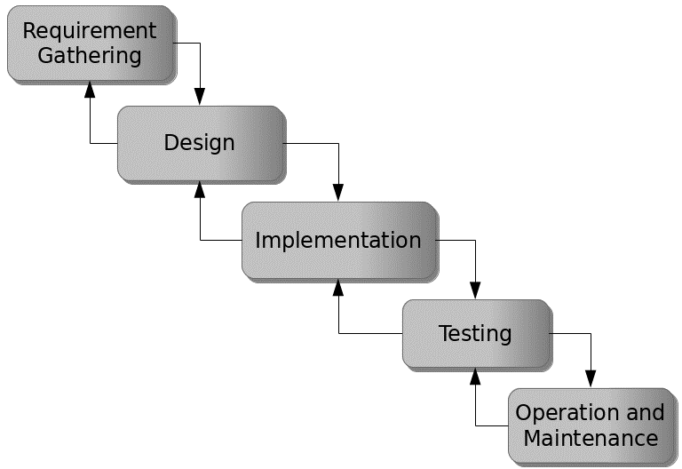

Figure 3.1: Waterfall model

## 3.5 Method of Data Collection

Data collection for the development of the Library management system were both primary and secondary sources. Primary sources include direct interactions with stakeholders, such as interviews and surveys, to gather requirements and feedback. Secondary sources encompass existing literature, research, and relevant documentation related to online tutoring platforms and system development.

## 3.6 System Design

System design for the Library management system involves defining the platform's architecture, modules, interfaces, and data structures to meet specified requirements. It entails the application of systems theory to product development, ensuring the alignment of design elements with the objectives and needs of the Restaurant Reservation system.

## 3.6.1 Algorithm Diagram

**Use case diagram**

A use case diagram shows the system and the various ways that they interact with the system.

**DIGITAL LIBRARY SYSTEM**

Login

Add New Book

Add category

Admin

Student

Add course

Add Student

Borrow Book

Return Book

Stop

Figure 3.2: Use Case Diagram

**3.6.2 System Architecture**

Database MySQL

Apache Server

Library Management System



Figure 3.3: System Architecture

## 3.6.3 Database Tables/Queries Structures

The database is used to store all information that pertain the Library Management System records. Below are the database table for the new system.

**Table 1: Book Table**

Top of Form

| **Name** | **Type** | **Extra** |
| --- | --- | --- |
| id Primary | int(11) | AUTO_INCREMENT |
| categor_id Primary | int(11) |  |
| title | varchar(250) |  |
| author | varchar(250) |  |
| publisher | varchar(250) |  |
| published date | date |  |
| isbn | varchar(40) |  |
| status | int(5) |  |
| Date | timestamp |  |

**Table 2: Admin table**

**Top of Form**

| **Name** | **Type** | **Extra** |
| --- | --- | --- |
| id Primary | int(11 | AUTO_INCREMENT |
| Name | varchar(50) |  |
| username Index | varchar(50) |  |
| password | varchar(50) |  |
| contact | bigint(11) |  |
| photo | varchar(50) |  |
| Date | timestamp |  |

**Table 3: Booking Status**

Top of Form

| **Name** | **Type** | **Extra** |
| --- | --- | --- |
| id Primary | int(11) | AUTO_INCREMENT |
| Registration no | varchar(250) |  |
| Firstname | varchar(250) |  |
| Lastname | varchar(250) |  |
| Course id | varchar(250) |  |
| Photo | varchar(250) |  |
| Date | timestamp |  |

**Table 4: Book Category**

Top of Form

| **Name** | **Type** | **Extra** |
| --- | --- | --- |
| id Primary | int(11) | AUTO_INCREMENT |
| name | varchar(250) |  |
| Date | timestamp |  |

Bottom of Form

**Table 5: Course**

Top of Form

| **Name** | **Type** | **Extra** |
| --- | --- | --- |
| id Primary | int(11) | AUTO_INCREMENT |
| title | varchar(20) |  |
| code | varchar(50) |  |
| Date | timestamp |  |

**Table 6: Borrow**

Top of Form

| **Name** | **Type** | **Extra** |
| --- | --- | --- |
| id Primary | int(11) | AUTO_INCREMENT |
| student_id | int(11) |  |
| book_id | int(11) |  |
| status | int(11) |  |
| Date | timestamp |  |

Bottom of Form

## 3.6.4 Database Entity Relationship Diagram

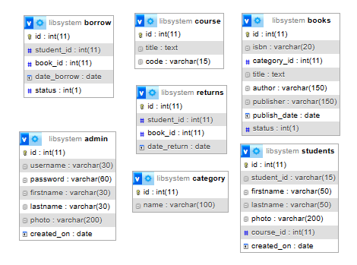

Figure 3.4: Database Entity Relationship Diagram

## 3.6.6 Input and Output Design

**ADD STUDENT FORM**

Registration number

Last name

**SAVE**

First name

Course of study

Level

Photo

**CLOSE**

Figure 3.5: Add Student Form

**ADD CATEGORY**

Category name

**SAVE**

Figure 3.6: Add category

| Registration No | Name | Level | Course of study |
| --- | --- | --- | --- |
| ST/CS/ND/22/033 | MUSA ADAMU | ND | Computer Science |
| ST/CS/ND/22/434 | AUWAL AMOS | ND | Computer Science |

Figure 3.7: Student records

**BORROW**

Student Registration number

Book ISBN

**SAVE**

Figure 3.8: Borrow Book Form

**ADD BOOK FORM**

ISBN

Author

**SAVE**

Title

Publisher

Published date

Category

**CLOSE**

Figure 3.9: Add Book Form

## 3.7 System Requirement Specification

## 3.7.1 Hardware Requirements

The software to be design needs the following hardware for an effective operation of the newly designed system.

1. A system running on intel, P(R) duo core with higher processor
2. The-Random Access Memory (RAM) should be at least 512MB.
3. At least 20-GB hard disk.
4. A monitor.

## 3.7.2 Software Requirements

The software requirements include:

1. A window 7 or higher version of operating system.
2. XAMP or WAMP for Database
3. PHP
4. MySQL
5. Browser

## 3.7.3 Personnel Requirement

Any computer literate who has a technical knowhow of internet surfing can use the system because it is user friendly.

# CHAPTER FOUR

# RESULTS AND DISCUSSION

## 4.1 Introduction

This chapter presents the results and discussions of the newly developed system, which utilizes PHP and MySQL for efficient record insertion and updating. The system is designed to streamline the management and retrieval of information, thereby enhancing operational efficiency. In this chapter, we will explore the functionality and performance of the system, discussing its impact on data management and its effectiveness in meeting the intended objectives.

## 4.2 Results

**4.2.1 Welcome Interface**

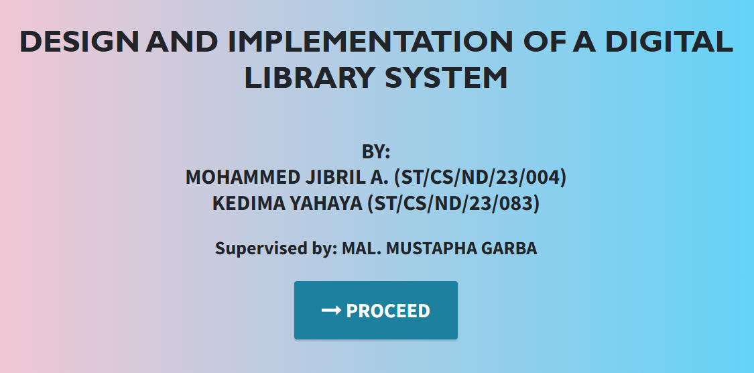

Figure 4.1: Welcome Interface

Figure 4.1 shows the welcome page of the Computerized Library Management System, the welcome page is the first page that displays the project topic.

**4.2.2 Login interface**

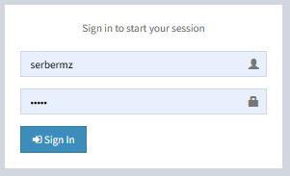

Figure 4.2: Login interface

Figure 4.2 above represents the user interface and workflow for gaining access into the system by entering the username and password.

**4.2.3 Add New Book**

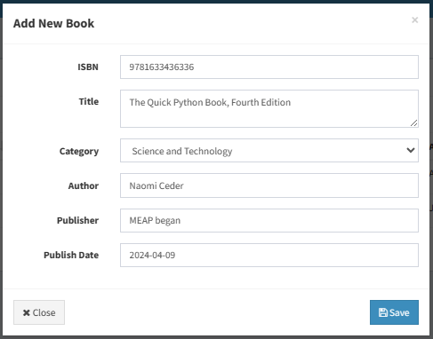

Figure 4.3: Add New Book

Figure 4.3 above shows where a new book can be added into the system by providing details like the ISBN, Title, Category, etc.

**4.2.4 Borrow Book Interface**

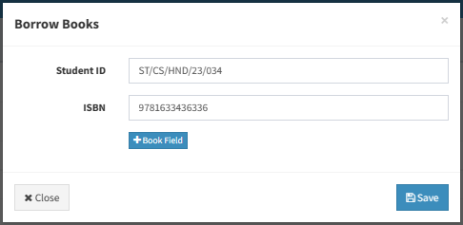

Figure 4.4: Borrow Book

Figure 4.4: Borrow book interface shows the user interface where a book can be borrowed to a student using the student registration number and book ISBN number.

**4.2.5 Book list**

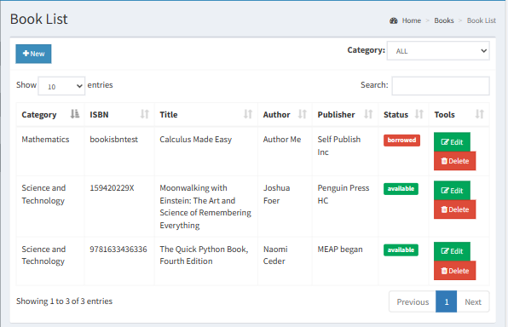

Figure 4.5: Book list interface

Figure 4.5 shows all records of books that are in the system showing the category, ISBN, the tile, author and publisher.

**4.2.6 Dashboard interface**

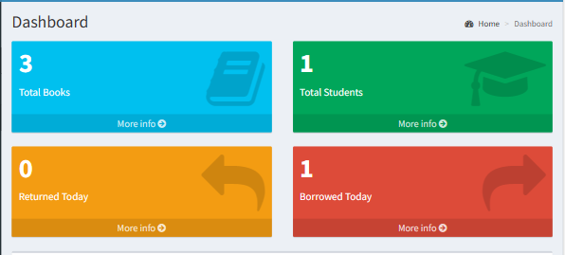

Figure 4.6: Dashboard interface

Figure 4.2.6 above depicts the main dashboard interface of the Library management system. The dashboard provides an overview of the library management system.

## 4.3 Discussion

The Welcome Interface serves as the entry point to the system. It provides users with an initial view of the application, typically featuring the system's name, a brief description, and navigation options. The interface is designed to be user-friendly and engaging, ensuring that users can easily identify the purpose of the system and proceed to the next steps, such as logging in or exploring more about the system.

The Login Interface is a critical security component of the system. It requires users to authenticate themselves by entering their credentials, typically a username and password. This interface ensures that only authorized personnel can access the system's functionalities, protecting sensitive information from unauthorized access. The interface may also include options for password recovery and user registration.

The Add New Book Interface allows users to input details about new books into the system's database. This interface typically includes fields for the book's title, author, ISBN, publication date, genre, and other relevant information. The interface is designed to be straightforward, enabling users to efficiently add new entries without encountering unnecessary complications.

The Borrow Book Interface facilitates the process of lending books to users. It allows librarians or users to record the borrowing transaction by selecting a book from the inventory and associating it with a borrower. This interface typically includes fields for the borrower's details, the book's identification, and the due date for return. The interface ensures accurate tracking of borrowed books and helps manage the lending process effectively.

The Book List Interface provides a comprehensive view of all books available in the system. It displays detailed information about each book, including its status (available, borrowed, reserved), and may include search and filter options to help users quickly find specific books. This interface is essential for inventory management and for users looking to explore the library's collection.

The Dashboard Interface offers an overview of the system's key metrics and activities. It typically includes widgets or panels displaying statistics such as the number of books available, books borrowed, overdue books, and user activity. The dashboard provides a centralized location for users, especially administrators, to monitor the system's performance and access important functions quickly. It is designed to be visually appealing and informative, aiding in effective decision-making and management.

These interfaces collectively provide a high-level overview of the key functionalities and interfaces in a restaurant reservation system, emphasizing the user experience and operational efficiency.

## 4.4 User manual

## 4.4.1 System Installation

The user manual is a clear and precise instruction on how a user can operate the propose system, without any stress and successful. The following steps required

1. Start or boot the computer form the hard disk
2. Double click on the folder that program is been stored in the desktop
3. Double click on the program and allow it to load gently
4. A security unit will display were the user will specify the user name and password the click on OK.
5. A welcome menu will be displayed where the user has options to select which operation to be performed.
6. To find information about player, select any name and search.
7. Click on exist on the welcome screen to exist from the program.

## 4.4.2 System Installation

The following are the necessary steps to take in order to use the system efficiently and effectively.

1. Load the url of the system <https://localhost/library/> the welcome page will be displayed.
2. Click on the **Proceed** button to proceed to the main system.
3. If you created an account, provide your login details by entering your username and password.
4. Depending on the login details provided you will be automatically directed to the dashboard.
5. The various task that you can perform on the portal will be displayed on the sidebar of the dashboard.

# CHAPTER FIVE

# SUMMARY, CONCLUSION AND RECOMMENDATIONS

## 5.1 Summary

This chapter provides a comprehensive overview of the digital library system, highlighting key findings and outcomes. The system was designed to streamline library operations for both patrons and staff, incorporating functionalities such as checking book availability, borrowing books, adding new books, and viewing detailed inventory information. The implementation of a user-friendly interface and robust backend infrastructure aimed to enhance the efficiency and user experience in managing library resources.

## 5.2 Conclusion

The computerized library management system effectively addresses the challenges faced by both patrons and library staff in managing library resources. By providing a centralized platform for borrowing and managing books, the system reduces errors, minimizes the risk of lost books, and improves overall operational efficiency. The implementation of various interfaces, such as book availability check, book borrowing, book addition, and detailed inventory views, ensures that all aspects of library management are covered. The project has demonstrated the feasibility and benefits of using a digital solution to streamline library operations.

## 5.3 Recommendations

Based on the findings and outcomes of this project, the following recommendations are proposed:

1. Continuously improve the user interface to ensure ease of use and accessibility for all users, including those with disabilities.
2. Implement automated reminders for book returns to reduce overdue books and improve return rates.
3. Develop a mobile application version of the system to provide greater convenience and accessibility for patrons on the go.
4. Implement a feedback system where patrons can rate their experience and provide suggestions for improvement, helping the library to continuously enhance its services.

# REFERENCES

Abrizah, A., Yusof, S. N., & Ibrahim, A. G. (2015). Open source library management systems: A review of their functionalities and the factors for successful implementation. *International Journal of Digital Library Systems,* 7(4), 323-340.

Al-Harbi, A. M., & Al-Harbi, H. M. (2021). A comparative analysis of manual versus computerized library management systems in Saudi Arabian academic libraries. *Journal of Information Science,* 47(2), 382-398.

Bing, X., Yu, H., & Zhang, Y. (2022). A survey on cloud-based library management systems. *Journal of Library and Information Technology*, 43(2), 121-132.

Brewerton, D., & Gilchrist, A. (2018). *The essential guide to library information management* (2nd ed.). Facet Publishing.

Chen, Q., Wu, J., & Wang, Y. (2023). Library management system based on blockchain technology. *IEEE Access,* 11, 10122-10132.

Chowdhury, G. G., & Chowdhury, S. (2020). *Introduction to library and information science* (12th ed.). Libraries Unlimited.

Delen, D. (2021). *Business analytics for managers* (5th ed.). Pearson Education Limited.

Evans, J. A., & Alire, C. A. (2018). *Introduction to library automation* (2nd ed.). Libraries Unlimited.

Ghazal, A., Zomaya, A., & Tahvildari, L. (2020). A survey on NoSQL databases for big data. *Journal of Parallel and Distributed Computing,* 143, 1-17.

Hughes, G. (2019). *Database systems for information retrieval*. Routledge.

Johnson, M., & Patel, J. (2021). Cloud-based information management systems for bakeries: A case study approach. *International Journal of Information Management,* 59, 102422.

Kaplan, M. (2019). *Information technology and libraries* (8th ed.). Libraries Unlimited.

Khumalo, V. M. (2020). Information management systems and knowledge management systems: A literature review. *Knowledge Management & E-Commerce,* 1(2), 311-324.

Kumar, A. (2018). Management theory: An introduction. Vikas Publishing House.

Laudon, K. C., & Laudon, J. P. (2016). *Management information systems: Managing the digital firm* (15th ed.). Pearson Education Limited.

Mehra, P., Singh, R. K., & Rani, A. (2019). *Next-generation library management systems*: A review of the literature. Library Hi Tech, 37(3), 438-454.

Motahari-Nezhad, H. R., Liu, Z., Ding, X., & Jääl, A. (2021). Security and privacy issues in cloud-based database management systems: A survey. *ACM Computing Surveys (CSUR),* 54(2), 1-41.

Nguyen, T. T. H., & Tran, L. N. (2020). The impact of integrated information management systems on bakery performance. *Journal of Business & Economics Research*, 12(1), 187-199.

Obejesi, T. I., Anumnu, N. J., & Nwagwu, M. A. (2022). Cloud-based library management systems: A review of functionalities and benefits. *International Journal of Library and Information Science Studies,* 10(1), 1-10.

O'Brien, J. A. (2015). *Introduction to information systems* (20th ed.). Pearson Education Limited.

Powell, J. R. (2019). *Library user services and access management* (4th ed.). Libraries Unlimited.

Ramakrishnan, R., & Gehrke, J. (2020). *Database management systems* (8th ed.). Pearson Education Limited.

Rubin, R. E. (2015). *Foundations of library and information science* (5th ed.). Libraries Unlimited.

Sharma, P., & Dangi, N. (2020). Impact of library management system on library services and user satisfaction in academic libraries. *Library Philosophy and Practice*, 1(2), 1-8.

Tanenbaum, A. S., & Woodhull, A. S. (2015). *Structured computer organization* (6th ed.). Pearson Education Limited.

# APPENDIX A

Welcome interface



Login interface



Add New Book



Borrow Book Interface



Book list



Dashboard interface



# APPENDIX B

**PROGRAM CODE**

<?php

include 'connection.php';

if($_SERVER["REQUEST_METHOD"] == "POST") {

if(isset($_POST['removeBooking'])) {

        $bookId = $_POST["bookId"];

        $sql = "DELETE FROM `tbl_booking` WHERE `booking_id`='$bookId'";

        $sql2 = "DELETE FROM `tbl_booking_status` WHERE `booking_id`='$bookId'";

        $result = mysqli_query($conn, $sql);

        $result2 = mysqli_query($conn, $sql2);

        if ($result && $result2){

            echo "<script>alert('Removed.');

                window.location=document.referrer;

                </script>";

        }

        else {

            echo "<script>alert('Failed.');

                window.location=document.referrer;

                </script>";

        }

    }

}

?>

<!-- Modal -->

<div class="modal fade" id="bookingStatus" tabindex="-1" role="dialog" aria-labelledby="bookingStatus" aria-hidden="true">

  <div class="modal-dialog" role="document">

    <div class="modal-content">

      <div class="modal-header" style="background-color: rgb(111 202 203);">

        <h5 class="modal-title" id="bookingStatus">Booking Status </h5>

        <button type="button" class="close" data-dismiss="modal" aria-label="Close">

          <span aria-hidden="true">&times;</span>

        </button>

      </div>

      <div class="modal-body">

        <?php

        $book_status_Sql = "SELECT * FROM `tbl_booking_status` where booking_id='$bookingid'";

        $bookstatusResult = mysqli_query($conn, $book_status_Sql);

        $bookstatusRow = mysqli_fetch_assoc($bookstatusResult);

        ?>

        <form action="partials/_bookingManage.php" method="post" >

                <div class="text-left my-2">

                <b><label for="name">Booking Status:</label></b>

                <div class="row mx-2">

                    <select class="form-control col-md-12" id="bookStatus" name="status" required>

                    <option value="">Select Status</option>

                    <?php

                     if($bookstatusRow['booking_status']==1){

                    ?>

                    <option value="1" selected>Booking Confirmed</option>

                    <option value="2">Booking Cancelled</option>

                <?php }

                else if($bookstatusRow['booking_status']==2){ ?>

                    <option value="1">Booking Confirmed</option>

                    <option value="2" selected>Booking Cancelled</option>

              <?php  } else {?>

                <option value="1">Booking Confirmed</option>

                <option value="2">Booking Cancelled</option>

                <?php } ?>

                </select>

                </div>

            </div>

            <div class="text-left my-2" id="tableNo">

                <b><label for="name">Table Number:</label></b>

                <div class="row mx-2">

                <select class="form-control col-md-12" id="tableValue" name="table_no" required>

    <option value="">Select Table Number</option>

    <?php

    // Ensure that $conn is a valid database connection

    if ($conn) {

        // SQL query to get available table numbers

        $tableSql = "SELECT * FROM `tbl_table` WHERE table_no NOT IN (SELECT table_no FROM tbl_booking_status)";

        $tableResult = mysqli_query($conn, $tableSql);

        if ($tableResult) {

            while ($tableRow = mysqli_fetch_assoc($tableResult)) {

                // Pre-select table number if it matches with $bookstatusRow['table_no']

                // Ensure $bookstatusRow is defined and accessible

                $selected = (isset($bookstatusRow) && $tableRow['table_no'] == $bookstatusRow['table_no']) ? "selected" : "";

                echo "<option value=\"{$tableRow['table_no']}\" $selected>{$tableRow['table_no']}</option>";

            }

        } else {

            // Handle query execution error

            echo "<option value=\"\">Error fetching table numbers</option>";

        }

    } else {

        // Handle database connection error

        echo "<option value=\"\">Database connection error</option>";

    }

    ?>

</select>

                </div>

            </div>

            <div class="text-left my-2">

                <b><label for="name">Remarks:</label></b>

                <div class="row mx-2">

                <textarea class="form-control col-md-12" id="remarks" name="remarks" required>

<?php

    // Check if $bookstatusRow is defined and 'remarks' is set

    if (isset($bookstatusRow) && isset($bookstatusRow['remarks'])) {

        // Use htmlspecialchars to prevent issues with special characters

        echo htmlspecialchars($bookstatusRow['remarks']);

    } else {

        // Optionally, handle the case where 'remarks' is not set

        echo "";

    }

?>

</textarea> </div>

            </div>

            </div>

            <input type="hidden" id="bookId" name="bookId" value="<?php echo $bookingid; ?>">

            <button type="submit" class="btn btn-success mb-2" name="updateStatus">Update</button>

        </form>

        </div>

    </div>

  </div>

</div>

<script src="http://ajax.googleapis.com/ajax/libs/jquery/1.9.1/jquery.min.js"></script>

<script>

    $(function () {

        $('[data-toggle="popover"]').popover();

    });

</script>

<script type="text/javascript">

    $('#tableNo').hide();

    $(document).ready(function(){

    $('#bookStatus').change(function(){

   if($('#bookStatus').val()==1)

  {

     $('#tableNo').show();

     $('#tableValue').prop('required',true);

  }

  else

  {

    $('#tableNo').hide();

    $('#tableValue').val('');

    $('#tableValue').removeAttr('required',false);

  }

})

})

</script>